PROJECT -9
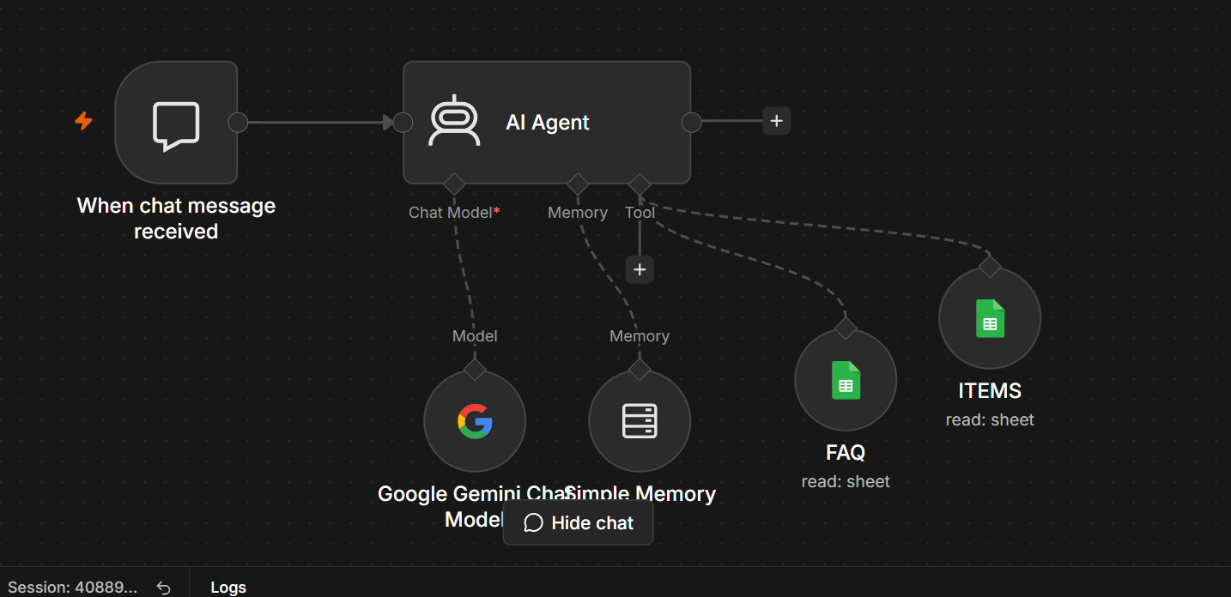
Project Title
AI Customer Support Chatbot Using Google Gemini and Google Sheets

Project Overview
This workflow implements an AI-powered chatbot that answers user queries using Google Gemini as the language model and Google Sheets as its knowledge base. The chatbot is triggered whenever a user sends a chat message, retrieves relevant information from Google Sheets (FAQs and Items), maintains conversation context using memory, and generates intelligent responses.
The system is suitable for customer support, internal knowledge bases, product inquiries, and FAQ automation.

Workflow Architecture
User
│
▼
When Chat Message Received
│
▼
AI Agent
┌────────┼────────┐
│ │ │
▼ ▼ ▼
Google Gemini Memory Google Sheets
Chat Model (FAQ & ITEMS)
│
▼
AI Generated Response
│
▼
User

Workflow Components
1. When Chat Message Received
Purpose
Acts as the entry point of the chatbot workflow. The workflow starts automatically whenever a user sends a message.
Function
- Receives the user's chat input.
- Passes the message to the AI Agent for processing.
Input
User message.
Output
User query sent to the AI Agent.

2. AI Agent
Purpose
The AI Agent is the core component responsible for understanding user queries, retrieving relevant information, maintaining context, and generating accurate responses.
Responsibilities
- Understands user intent.
- Uses Google Gemini to generate responses.
- Retrieves relevant information from Google Sheets.
- Maintains conversational memory.
- Combines retrieved knowledge with AI reasoning.
Input
- User message
- Chat history (Memory)
- FAQ data
- Item data
Output
Natural language response returned to the user.

3. Google Gemini Chat Model
Purpose
Provides the Large Language Model (LLM) used by the AI Agent.
Responsibilities
- Understands natural language.
- Generates context-aware responses.
- Summarizes information when needed.
- Answers questions using retrieved knowledge.
Features
- Multi-turn conversation support.
- High-quality natural language generation.
- Context-aware reasoning.
- Intelligent question answering.

4. Simple Memory
Purpose
Stores previous messages exchanged during the conversation to maintain context.
Why Memory is Required
Without memory:
- Every question is treated independently.
- Follow-up questions lose context.
With memory:
- The chatbot remembers previous interactions.
- Supports natural multi-turn conversations.
- Improves response relevance.
Example
User: What is Item A?
Bot: Item A is a wireless keyboard.
User: What is its price?
The chatbot understands that "its" refers to Item A because of the stored conversation history.

5. FAQ Google Sheet
Purpose
Stores frequently asked questions and their corresponding answers.
Example Data
Question | Answer
What are your working hours? | Monday to Friday, 9 AM – 6 PM
How can I contact support? | Email: support@example.com
Do you offer refunds? | Yes, within 30 days
Function
- Searches the FAQ sheet for relevant answers.
- Supplies matching information to the AI Agent.

6. ITEMS Google Sheet
Purpose
Stores product or inventory-related information.
Example Data
Item ID | Item Name | Price | Stock
101 | Laptop | $850 | 15
102 | Keyboard | $40 | 120
103 | Mouse | $25 | 75
Function
- Retrieves item details based on user queries.
- Enables the chatbot to answer product-related questions.

Workflow Execution Flow
Step | Component | Purpose
1 | When Chat Message Received | Receives user input
2 | AI Agent | Processes the query
3 | Google Gemini Chat Model | Generates intelligent responses
4 | Simple Memory | Maintains conversation context
5 | FAQ Google Sheet | Retrieves FAQ information
6 | ITEMS Google Sheet | Retrieves product/item information
7 | AI Agent | Combines retrieved data with AI reasoning
8 | User | Receives the final response

Example Conversation
User
What are your working hours?
Chatbot
We are open Monday to Friday from 9:00 AM to 6:00 PM.

User
Tell me about the wireless keyboard.
Chatbot
The wireless keyboard is available for $40 and currently has 120 units in stock.

User
Is it available?
Chatbot
Yes, the wireless keyboard is currently in stock with 120 units available.

Advantages
- Real-time AI-powered responses.
- Uses Google Sheets as an easy-to-manage knowledge base.
- Maintains conversation context with memory.
- Reduces manual customer support effort.
- No coding required to update FAQs or product information.
- Scalable by adding more Google Sheets or external data sources.
- Supports multi-turn, natural conversations.

Use Cases
- Customer Support Chatbot
- Product Information Assistant
- Internal Knowledge Base
- HR Helpdesk
- IT Service Desk
- Inventory Inquiry System
- Educational FAQ Bot
- E-commerce Assistant

Future Enhancements
- Integrate with a SQL database or CRM for dynamic data retrieval.
- Add Retrieval-Augmented Generation (RAG) using vector databases for semantic search.
- Support multilingual conversations.
- Include user authentication and role-based access control.
- Integrate with Slack, Microsoft Teams, WhatsApp, or Telegram.
- Log conversations for analytics and performance monitoring.
- Enable voice input/output for conversational AI assistants.

